**\*\*All the red text is just to explain the flow of the website and the slides**

The Medicom website

Main page

MediCom is an innovative program which has all your health information at one click. This comprehensive website will track the medications you’ve taken and basic health information.

Out of the many factors which can influence your health, medication adherence is one you can control. Medication adherence is defined as the extent to which a person takes **medications** as prescribed by their healthcare providers.

The term Medication non-adherence is the lack of adherence to medication protocols.

There are two important contributors to medication non-adherence: the patient-provider relationship and the following of medication protocols.

Having an open and honest relationship with your health provider can improve your overall experience as a patient. Being able to talk openly about concerns and questions regarding medication can be helpful. A lot of people, however, do not have the opportunity to establish a meaningful relationship with their health care provider.

Unfortunately, when it comes to following medication protocols, over 50% of patients either never fill their prescription, delay refills, discontinue or skip doses. This contributes to almost 70% of hospital admissions.

Hence, MediCom is the key to making patients healthier and doctors happier.

Image slides: By clicking on the images, the website would open the specific page with all the information associated with that image.

1. Administrator-shows the benefits of using Medicom as an administrator
2. Patients-shows the benefits of using Medicom as a patient
3. All the devices
4. App
5. **Administrator**



Medication compliance is an issue that presents lots of problems in today’s medical field. MediCom will create a common space where doctors and patients can view and track important information such as symptoms, medication and exercise. This will be done by tracking the user’s health while they take the medication using the three devices, fitbit, blood pressure monitor and MEMS pill cap, as well as a symptom tracking app.

The MediCom platform will be able to show the doctor and patient when they took the medication, what their blood pressure was, and if they had any symptoms/side effects. Based on that information, patients can either continue the treatment after that time or talk to the doctors about trying a new one.

The entire health information will be accessed at One Click. This enables high-quality conversation between patients and provider.

1. **Patients**



MediCom allow patients to be more active and informed about their health. It increases the patient’s role in their own health decisions and makes a more honest discussion during appointments. Many times patients are hesitant to ask questions or are unable to explain their concerns about their medication, hence Medicom will fill in that gap by helping them understand how a certain medication is working for them.

Using the symptom tracking app patients will be tracking their symptoms to help identity when their health condition is getting worse or when do they feel the side effects.

Recording the symptoms with severity level at any given time would provide more accuracy when patients meet the doctor to discuss their experience with the medication.

Having a clear understanding of how the medication is improving patients’ health encourages patients to take their medication especially when they are able to see the times they do take and when they do not take the medications.

1. **The Devices**

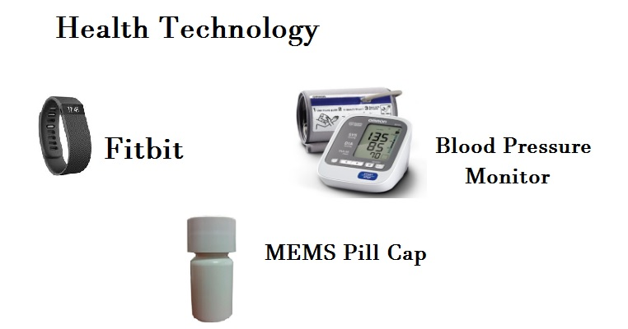

How to Use MediCom’s devices.

Blood Pressure Monitor:

The Omron 7 Series wireless upper arm Blood pressure monitor will record your blood pressure during the trial period (insert times of collection here). The basic functions of this monitor are simple, but there are a few key things to should watch out.

There are 2 parts to the Omron blood pressure monitor:

* 1. The device body and
  2. The removable arm cuff.

The device body is a small square-shaped unit which has an enlarged screen that will show the systolic and diastolic blood pressure at a given time. The main part of the device body has several buttons.

The start/stop button is located on the lower right hand side of the device body. On the left side of the device body, there is a switch that has the symbol of a person and a number next to it. When the patient receives the blood pressure monitor, the device will be set to a specific Person number setting.

Please do not change the Person setting at any time during the trial period.  The Omron blood pressure monitor comes equipped with a removable arm cuff which has a cable that connects to the device body.

Fitbit Charge:

This is an activity tracker which will keep track of the patients’ sleep and exercise with details such as the number of steps taken to calories burned for the trial period. The fitbit charge is set up via fitbit connect software, therefore there is no need for manual submission of the data. However, in order to obtain accurate data, there are certain things we need to take care of.

1. The wristband should be placed with the screen being closest to the outside of the wrist and facing the patient. Both pegs on the clasp must be  inserted completely  for the fitbit to be fully secure.
2. The patients need to keep the fitbit clean especially after a sweaty workout or after applying lotion or soap to the skin. The fitbit is waterproof but still patients need to avoid using it while taking a shower or swimming.

The battery life is about 7- 10 days and when there is a need to charge the fitbit, insert the charging cable into the usb port on either a computer or a charger and plug the other end into the port on the back of the charger.

MEMS Pill Cap:

This bottle will keep the record of how many times the cap is opened. By tracking the number of times the bottle is opened, the healthcare provider will be able to monitor the patient's’ drug dosage.

*At the end of the trial period, all devices and device accessories must be returned to the healthcare provider. If there are any technical difficulties experienced during the trial period, contact the healthcare provider right away.

1. **Symptom App**

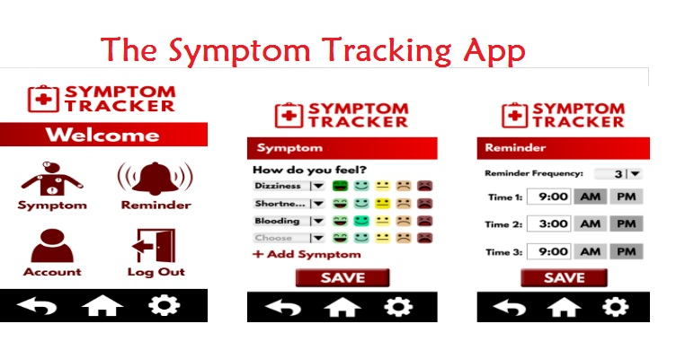

You may edit the image based on the final look if the App ( I used Paint to edit the image)

The Medicom symptom app is designed to keep track of the patient's’ health by allowing them to record their symptoms and use the scale of severity of certain symptom such as headache.

Notification will be delivered to remind patients to submit their current feelings related to the symptoms.

Suggestion regarding specific symptoms will be provided to the patients based on the type of prescribed medicine, but they also have the option to add more symptoms other than the ones suggested.